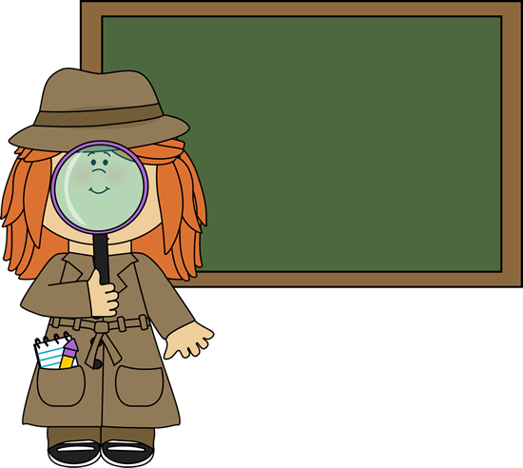



**Welcome to the 3rd, 4th, 5th, and 6th classroom!**

The purpose of this letter is to inform you what materials you will need. All materials will need to be bought by August 26 (if you could have them by the first day of school would be great). Additional material might be needed throughout the year.

**Material:**

* 2 notebooks (green and blue)
* 2 regular 2 pocket folder
* Pencils; they can be mechanical
* Erasers
* 2 boxes of tissues per family
* Extra pair of shoes (for PE and during wet/muddy seasons)

**Optional**

* Highlighters- two different colors
* Color pencils or crayons (if you get too much you will run out of room in your desk)
* Scissors, Ruler, Glue
* Water bottle, the needs to be water tight (no spills)

**NOTE**: 3-ring binders are too large to fit in the desk and usually cause more problems than are helpful. You will not need one.

If you have any problems getting the material, please let me know. ~Miss Brown

P.S. You can get a hold of me at school or through my email: hbrown_4_school@yahoo.com